13.100: Let the two distances from the center of mass be 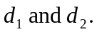There are then two relations of the form of Eq. (13.39); with 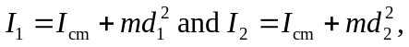 these relations may be rewritten as

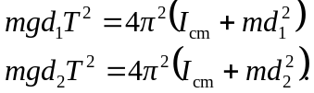

Subtracting the expressions gives

and dividing by the common factor of 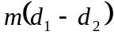 and letting 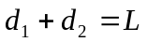 gives the desired result.

